**Record of Activity**

Week 1 (25.11.2019 – 29.11.2019):

* I familiarized myself with Julia and Eirene. Specifically, I read the paper *Persistent and Zigzag Homology; A Matrix Factorization Viewpoint* (<https://arxiv.org/abs/1911.10693>) and implemented up to algorithm 3 in Julia. The implementation of cellular complexes is my own and might not currently be compatible with Eirene but I think it could be easily adapted. A brief description for each of the algorithms I implemented is:

1. The Reduction Algorithm: given an $m×n$ matrix $A$, return a factorization $AU=R$ where $U$ is upper triangular and no two columns of $R$ share the same non-zero pivot. This algorithm is used to compute homology-revealing bases for a cellular complex.
2. Given the reduced boundary matrices (the matrices $R_{i}$ obtained from the Reduction Algorithm applied to the boundary matrices for the cellular chain complex), compute homology-revealing bases for a cellular complex. I chose to implement this algorithm as simply taking the standard boundary matrices and then reducing them by making a call to the Reduction Algorithm so that users did not have to deal with multiple input types for different algorithms.
3. Compute the induced map on homology in terms of the homology-revealing bases from algorithm 2. It takes as input a chain map $F_{k}$ represented by matrices with respect to the original basis and returns the induced map ${\tilde{F}}_{k}$  as a matrix. I considered using this to compute the inclusion maps on different subcomplexes of graphs to see if any useful information could be retrieved, but my understanding is that persistent homology already extracts information from inclusion maps.

* I learned some of the underlying theory of persistent homology by reading the paper *Zigzag Persistent Homology and Real-valued Functions* (<https://www.mrzv.org/publications/zigzags/socg09/>). I tried some simple examples of computing zigzag persistence and also tried to apply the Diamond Principle. I proved an easy case of the Diamond Principle by utilizing the Mayer-Vietoris long exact sequence, as suggested in the paper by Carlsson et al. I was initially having difficulty computing the persistence barcode; I have read the proof that it exists and is unique but could find no intuitive explanations as to how to compute it by hand. I correctly guessed a few examples by trial-and-error until Yossi Bokor pointed out that, at least for the 1-dimensional simplicial complexes given by the graphs we’re working with, the 1-dimensional barcode just represents the birth times of different 1-cycles since the 1-cycles never die.
* Kate and I met to discuss the papers I’ve read. We also looked at some of Marian’s graphs and discussed which vertices could reasonably be considered bridges. I’ve decided that, as a starting definition, I will take a bridge to be any vertex that connects two densely connected clusters.

Week 2 (2.12.2019-6.12.2019)

* Kate wants to try computing the zigzag persistence of the distance function to a vertex: fix a vertex $v$ and for every other vertex $w$, define $μ_{v}\left(w\right)$ to be the length of the shortest path from $v$ to $w$. This can be computed quite easily in Julia using Djikstra’s Algorithm, which is pre-existing code. Since the function $μ_{v}$ also has to be defined on $1$-simplices, we set $μ_{v}\left(\left(w_{1},w_{2}\right)\right)=\max\left\{μ_{v}\left(w_{1}\right), μ_{v}\left(w_{2}\right)\right\}$. I initially forgot that to compute zigzag persistence with sublevelsets, we had to have $μ_{v}^{-1}\left(-∞,r\right]$ being a subcomplex for every $r∈R$. Consequently, I had the original definition of $μ_{v}$ on 1-simplices using min instead of max which gave inconsistent results.
* Kate and I spoke to Marian over Zoom and discussed some of the overarching goals of the project. He gave me access to the Jupyter notebook he used to generate the example graphs I’ve been working with. He has confirmed that a bridge is a vertex, not an edge, which is good because neither Kate nor I was certain about this.
* Yossi spent a day teaching me to use Eirene and in exchange, I’m going to give him the code I wrote based on the paper on matrix factorization. I now know how to use Eirene’s standard implementation for a cellular complex and also how to read Marian’s adjacency matrices from a file. I started writing some helper-functions for the algorithm, such as a function to build the induced subgraph of an annulus around a point. I also developed a preliminary test for bridges which is quite efficient but not hugely accurate. The idea is that, for a vertex $v$, we can take the neighbourhood of radius $d$ about $v$ and determine if removing $v$ disconnects the neighbourhood. If so, then $v$ is a ‘local bridge’ and hence is quite likely to be a global bridge. I am currently taking $d$ to be the distance from $v$ to the nearest cluster. This test works well for identifying lone bridges, but often fails to identify parallel bridges because they are in the same neighbourhood and so removing $v$ doesn’t disconnect the neighbourhood. Below is the first example I tried this algorithm on. The algorithm correctly identifies all of the bridges but also has a large number of false positives. This is fairly standard across all of the example graphs.

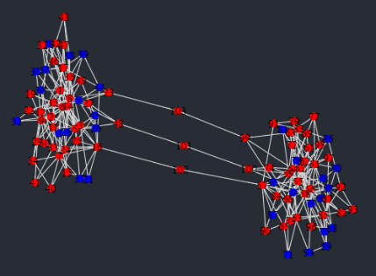

Week 3 (9.12.2019-13.12.2019)

* Kate suggested a test for bridges which I call the annulus test. It is a natural generalization of the neighbourhood test from last week in the following way: we consider the closed annulus $Δ\left(v,a,b\right)=\left\{w∈V :a≤μ_{v}\left(w\right)≤b\right\}$. If $Δ\left(v,a,b\right)$ is disconnected for sufficiently many values of $a$ and $b$ then $v$ is a local bridge. The neighbourhood algorithm described above is the special case of the annulus $Δ\left(v,1,d\right)$. The biggest problem is choosing the correct values of $a$ and $b$. I am currently trying to choose them so that the annulus contains only vertices in clusters (so that there are no parallel bridges).
* I have an idea for a different test that I’d like to try, although I probably won’t write code for it yet. It relies on the Wasserstein distance for persistence diagram given by

$$W_{p,q}\left(X,Y\right)=\inf_{\begin{aligned}φ:X→Y \\ a bijection\end{aligned}}{{\left(\sum_{a∈X}{{\left\|a-φ\left(a\right)\right\|}_{q}^{p}}\right)}^{1/p}}$$

Intuitively, the 1-dimensional persistence diagrams for a bridge and a cluster point should look quite different, and this is reflected in their Wasserstein distance. A cluster point should have a large number of births almost immediately because of the 1-cycles inside the cluster, whereas a bridge should have a period without many births (there may still be some 1-cycles born early because of parallel bridges forming loops, but there will be fewer and this is reflected in the Wasserstein distance). Once we have identified a few points that are definitely in clusters (i.e. finding a point right at the center using some other method), we can use the Wasserstein distance to find nearby points that look similar enough to be cluster points.

* I was taken on a tour of the Australian Signals Directorate facility and discussed my project with some of the staff. On the topic of identifying points in the center of clusters, one of them suggested using a classical graph value called the clustering coefficient. This is defined as $C_{v}=\frac{\#edges between neighbours of v}{\#possible edges between neighbours of v}$. For an undirected graph, we can give a more explicit formula: if a vertex $v$ has $N$ neighbours, there are $\left(\begin{matrix}N \\ 2\end{matrix}\right)=\frac{N\left(N-1\right)}{2}$ possible edges. The clustering coefficient for $v$ is thus given by $C_{v}=\frac{2×\#edges between neighbours}{N\left(N-1\right)}$. The clustering coefficient takes values in the range $\left[0,1\right]$. The closer it is to $1$, the more densely clustered the neighbourhood around $v$ is and so the more likely $v$ is to be a cluster point.
* I finished implementing the annulus test and tried it on Marian’s example graphs. Strangely, it either identifies the same vertices as the neighbourhood algorithm or it doesn’t identify any at all. I suspect that my choice of $a$ and $b$ is not optimal, but I can’t think of different values that might work better. I had a friend (Edmund Hofflin) from the computer science department look over my code to see if he could think of any possible optimizations; he suggested changing the way the induced subgraph of the annulus is implemented. I rewrote the code so that it does not rely on pre-existing packages and it is noticeably faster.
* Yossi and I discussed my persistence diagram idea and he agreed that it is theoretically sound. We realized that, when trying to identify vertices that are close to densely clustered points under the Wasserstein distance, we will also have to consider the actual distance between them. This is because the Wasserstein distance cannot tell when a graph is highly symmetric, so two points that are far apart might have similar persistence diagrams.

Week 4 (16.12.2019-20.12.2019)

* I implemented the algorithm based on the Wasserstein distance. The hardest part is identifying the cluster points at the beginning, so I’ll give an explanation of the current method: we start by computing the 1-dimensional persistence barcodes for each vertex $v$ based on the shortest distance function $μ_{v}$. Using this, we can generate a list of how many $1$-cycles are born at each time step. Since we want to find vertices right at the center of clusters, we check to see what proportion of vertices (a parameter which may depend on the graph, call it parameter $a$) are born before a certain time (call it parameter $b$). There is a final parameter, which is the upper limit on the Wasserstein distance between two points when trying to find the other cluster points. We will call this parameter $d$.
* 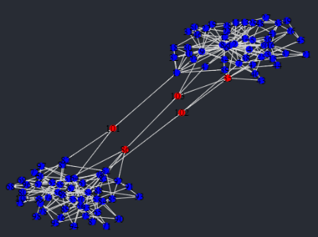I am using the implementation of the Wasserstein distance that already exists in Eirene. There is currently a problem with the code in the library because it cannot compare two persistence barcodes where none of the 1-cycles ever die (the program throws an error). As a temporary patch, I am replacing all of the death times with a large value $M∈R$ while Yossi tries to fix the problem. Below are the results of the new algorithm applied to Marian’s example graphs. Red vertices are bridges, blue are cluster points. I have included the values of $a,b$ and $d$ to show how they depend on the graph.

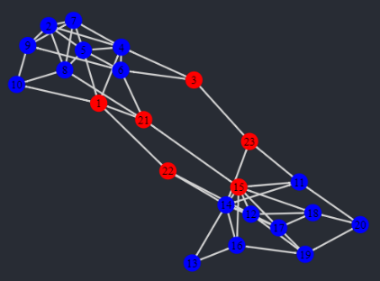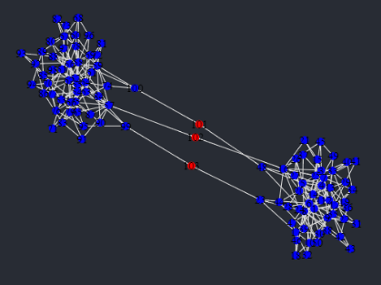

$$a=0.3$$

$$b=0.4$$

$$d=13$$

$$a=0.3$$

$$b=0.5$$

$$d=4.3$$

$$a=0.4$$

$$b=0.5$$

$$d=13$$

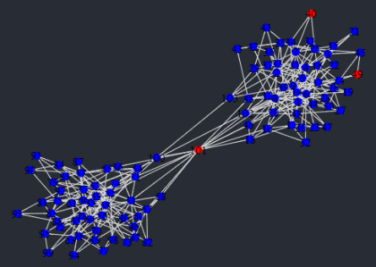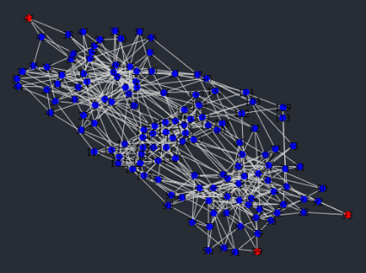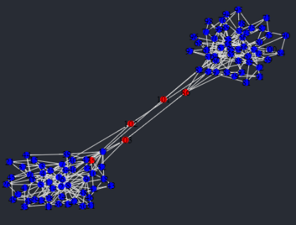

$$a=0.8$$

$$b=0.5$$

$$d=12$$

$$a=0.3$$

$$b=0.8$$

$$d=18$$

$$a=0.4$$

$$b=0.5$$

$$d=15$$

* Kate and I met and I showed her some of the above graphs. We talked about the algorithm and she pointed out that the lists of numbers of 1-cycles born at each time step are actually equivalent to the 1-dimensional persistence barcode, in the sense that there is a simple algorithm to convert back and forth between them. This is only true in the case of these 1-dimensional simplicial complexes because there are no 2-cells and so no 1-cycles ever die. She suggested that I try to work with these lists instead of the persistence barcode so that we do not need to use the Wasserstein distance, since this is the slowest part of the algorithm. She is going to send me some resources about cumulative distribution functions to see if we can use a similar (but more easily computed) metric on these lists to compare the vertices.

Christmas Break (23.12.2019-03.01.2020)

* I completely rewrote the code so that it no longer uses the Eirene package to compute the 1-dimensional persistence barcode. This is because there is a linear-time method of finding this barcode as follows: for sake of simplicity, we assume that our graph is connected. This should not affect which vertices are identified as bridges because being a bridge should only depend on the path-component. We now consider the Euler characteristic $χ$. It has been shown that, for a cellular complex such as a graph with $v$ vertices and $e$ edges, we have $χ=v-e=rank\left(H_{0}\right)-rank\left(H_{1}\right)$. Since $H_{0}$ counts path-components, this simplifies to $v-e=1-rank\left(H_{1}\right)$ and so $rank\left(H_{1}\right)=1-v+e$.
* Yossi fixed the problem of the Wasserstein distance algorithm breaking when presented with infinite death times. He has emailed me code to use in place of the package I imported since his pull request has yet to be accepted. I reran all examples using this new code to see if there was any difference when $∞$ was used in place of some $M∈R$. As expected, the values $a$ and $b$ remain the same (since they do not depend on the Wasserstein distance in any way) but the value $d$ needed to change slightly from example to example. Overall, I had to use a slightly larger value of $d$ to get the same optimal parameter choice.
* Now that the Wasserstein distance is working, I ran some timing tests. It is clear that the slowest part of the code by far is comparing the persistence diagrams. This is because the Wasserstein distance makes use of an algorithm for optimal matchings called the Hungarian algorithm, so if I want to make this code faster I would have to use a different optimal matching algorithm. I do not think this is very related to the homology part of the project so I will probably leave it to Marian unless he or Kate wants me to do it.
* I read the paper *Geometry Helps to Compare Persistence Diagrams* (<https://arxiv.org/abs/1606.03357>) to try to find other methods to increase the efficiency of the algorithm. I have not implemented any of these yet but may do so if I find time. Otherwise, Yossi says that he wants to do this in the future.

Week 5 (06.01.2020-10.01.2020)

* Kate and I met and discussed possible ways we could make the parameters $a,b$ and $d$ into something dependent on the graph (since currently I’m entering the parameters by hand). We’ve decided not to look into cumulative distribution functions because it requires a lot of background theory that I don’t have. Instead, we’re investigating some classical graph values to see if they can be related to $a$ and $b$. These are:

1. The Laplacian matrix $L$, which can be defined for a simple graph (an undirected graph with no edges from vertices to themselves) by the following formula:

$$L_{i,j}=\left\{\begin{aligned}\deg\left(v_{i}\right) if i=j \\ -1 if i≠j and v_{i} is adjacent to v_{j} \\ 0 otherwise\end{aligned}\right.$$

The Laplacian has several useful properties. It is symmetric and positive-semidefinite, so its eigenvalues are all real and nonnegative. Furthermore, its kernel counts the number of path-components in the sense that the multiplicity of the eigenvalue $λ=0$ is precisely the number of path-components in the graph. Since we are assuming our graph is path-connected, $λ=0$ will always have multiplicity 1.

Related to this is the spectral gap, defined to be the smallest non-zero eigenvalue of $L$. By the above, this will always be the second smallest eigenvalue. The spectral gap measures how well the graph can be bipartitioned, with smaller values of the spectral gap indicating there are only a few edges that need to be removed to divide the graph into two clusters. Below are the values of the spectral gap for the six example graphs from Week 4:

|  |  |
| --- | --- |
| **Graph Number** | **Spectral Gap** |
| 1 | 0.04790486355191601 |
| 2 | 0.32003014018672005 |
| 3 | 0.06929257191853444 |
| 4 | 0.04901961668043608 |
| 5 | 0.6258472922047704 |
| 6 | 0.1625182787552774 |

The clear outlier is graph 5 which is encouraging because this is the hardest graph in which to identify bridges. Even looking at the graph, I am unsure what constitutes a bridge.

The spectral gap can also be interpreted as a measure of the number of bridges between two clusters so it seems reasonable to believe there is a way to relate this to the values $a$ and $b$ used in the algorithm. However, because the spectral gap measures how well a graph can be partitioned into two clusters, graphs with more than two clusters will have to be treated differently.

The eigenvector corresponding to the spectral gap is called the Fiedler vector and it is often used to help bipartition the graph. Using the Fiedler vector, the $i^{th}$ vertex can be placed into a cluster by looking at the sign of the $i^{th}$ entry. It is worth noting that there is some choice here because any nonzero scalar multiple of an eigenvector is still an eigenvector. However, difference in sign is preserved under scaling (i.e. if $v_{i}$ and $v_{j}$ have different signs then so do $cv_{i}$ and $cv_{j}$ for any $c≠0$) so this property is well-defined. It is possible that looking at the Fiedler vector could be another method of identifying densely clustered points (instead of using $a$ and $b$) since ‘larger’ Fiedler entries correspond to vertices closer to the center of clusters. Again, because of the scaling, we will have to be careful about what ‘larger’ means.

1. There is a graph constant called the Cheeger constant. For a set of vertices $A⊆V\left(G\right)$, let $∂A⊆E\left(G\right)$ denote the collection of all edges from a vertex in $A$ to a vertex in $A^{c}$. The Cheeger constant is then given by

$$h\left(G\right)≔\min\left\{\frac{\left|∂A\right|}{\left|A\right|}:A⊆V\left(G\right),0<\left|A\right|<\frac{1}{2}\left|V\left(G\right)\right|\right\}$$

The Cheeger constant is strictly positive if and only if the graph $G$ is connected. We probably won’t end up using the Cheeger constant because it doesn’t give much information except that, for small values of $h\left(G\right)$, there exists a “bottleneck”, meaning there are two large sets of vertices with few edges between them. Although this is related to the existence of bridges, it does not help us identify the bridge vertices in any way.

* We’re also going to see how the current algorithm performs on a graph with more than two clusters, since this will be the more common situation. I’ve contacted Marian about this because his Jupyter code is specifically written to generate graphs with two clusters and bridges between them (with this in mind, I don’t really understand how graph 5 was generated). However, he’s away right now so I won’t be testing that this week.
* Kate suggested I try using superlevelsets instead of sublevelsets. This only requires a small modification to the code: as I remarked in Week 2, for any $r∈R$, $μ_{v}^{-1}\left[r,∞\right)$ needs to be a subcomplex. For superlevelsets, this means that we need to use min instead of max in the definition of $μ_{v}$ on edges. This change means that the persistence diagram for each point is different, although there are still the same number of 1-cycles. Having run the superlevelset code on the example graphs, the algorithm still identifies bridges but different values of $a$ and $b$ are now required (the same value of $d$ was still optimal). It seems like $1-a$ and $1-b$ are good values for the superlevelset algorithm, which seems quite reasonable intuitively.
* Yossi and I spent some time trying to optimize the Wasserstein distance code. There is an improvement over the general algorithm in the particular case of 1-dimensional graphs because 1-cycles never die. This means that there is no need for the sorting implemented in the Wasserstein algorithm. However, we still cannot avoid the need for the Hungarian algorithm, so although this optimization made a noticeable improvement, it did not completely solve the problem.

Week 6 (13.01.2020-17.01.2020)

* I spent a lot of this week trying to make the parameters $a,b$ and $d$ depend on the graph in a calculable way i.e. using a predetermined formula that does not require me manually entering values. Following on from last week, I tried using the Fiedler vector to replace the values $a$ and $b$. My solution to the problem of what ‘largest’ means was to take those vertices with Fiedler entry greater than the mean of the absolute value. That is, I took those $v_{i}$ such that $\left|Fe_{i}\right|>\frac{\sum_{j=1}^{n}{\left|Fe_{j}\right|}}{n}$. This property is well-defined up to scaling because, if we scale the entire Fiedler vector $F$ by some $c≠0$, we still have that

$$\left|\left(cF\right)e_{i}\right|=\left|c\right|\left|Fe_{i}\right| \\ >\left|c\right|\frac{\sum_{j=1}^{n}{\left|Fe_{j}\right|}}{n} \\ =\frac{\sum_{j=1}^{n}{\left|\left(cF\right)e_{j}\right|}}{n}$$

This method works quite well to identify the initial cluster points used in the algorithm. Below is a table showing the vertices identified with this method, those identified by the old method (with an appropriate choice of $a$ and $b$) and the final graph given by this method once a value for $d$ has been chosen. Observe that the value for $d$ is slightly less than the value from the old algorithm because, in general, more vertices are identified for the Fiedler vector as being cluster points. To see the final graph generated using the old method, look at Week 4 in this Record.

|  |  |  |
| --- | --- | --- |
| **Initial Vertices Using Old Algorithm (with $a$ and $b$)** | **Initial Vertices Using Fiedler Vector** | **Final Graph Using Fiedler Vector Vertices (with $d$)** |
| $$a=0.4,b=0.5$$ |  | $$d=12$$ |
| $$a=0.3,b=0.5$$ |  | $$d=2.4$$ |
| $$a=0.3,b=0.4$$ |  | $$d=11.1$$ |
| $$a=0.4,b=0.5$$ |  | Couldn’t generate the final version of this graph because the code was lost. |
| $$a=0.3,b=0.8$$ |  | $$d=4$$ |
| $$a=0.8,b=0.5$$ |  | $$d=13$$ |

* Overnight, Atom (my IDE) wiped blank all of the code relating to the project, including the backups. According to online forums (e.g. <https://discuss.atom.io/t/atom-crashed-and-my-source-file-ended-up-blank/16133/5>), Atom deletes the local copy of a file before saving the new one. However, if the IDE is interrupted in between these two processes, all copies of the file are lost. A Windows update was performed while I was asleep and it interrupted these processes. I spent all of yesterday (Thursday) and today rewriting the code based on these records.
* There is now a public GitHub repository at <https://github.com/OuroborosOfLife/Zigzag-Persistent-Homology> which all work related to the project will be regularly saved to.

Week 7 (20.01.2020-24.01.2020)

* Having rewritten the code, I have been comparing the new output graphs to the old ones. Interestingly, the output of the algorithm no longer seems to depend continuously on the parameter $a$ in the sense that increasing $a$ continuously no longer identifies more cluster points. Instead, the output depends discretely on $a$: if $a$ is above a certain threshold (generally $a>0.6$) then the algorithm identifies a set of initial cluster points. Otherwise, it fails to identify any cluster points at all. I cannot find a reason this should be happening, especially given that it wasn’t happening before we lost the code. Unfortunately, I cannot compare it to the old code. At least this change has the benefit of decreasing the number of parameters we have to deal with and the set of vertices it identifies when above the threshold is quite reasonable.
* One other unexpected change has come about because of rewriting the code. Using the old code, the algorithm would identify the following as the initial cluster points:

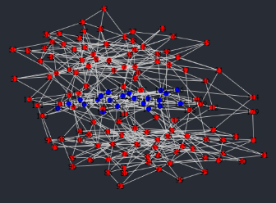

With the new code, however, we get these:

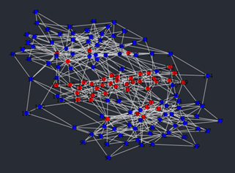

Kate and I have never been sure exactly what qualifies as a bridge in this graph (and others like it). However, this new output is much more in keeping with what Marian considers a bridge. The image below shows what Marian thinks the bridges in this graph are (the purple vertices):

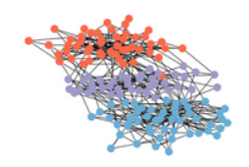

This is visibly closer to what the new code generated. I suspect that the reason for both of the changes I have described is that the algorithm is now weighting vertices differently depending on how far they are from the edge of the graph (which shows up in the persistence barcode as the length of the filtration). Since it seems to be working, I’m going to continue exploring this idea.

* It would probably be useful to summarise the stages of the algorithm to make it clear what the current approach is.

1. Identify a set of initial cluster points. For two-cluster graphs, this can be done using either the Fiedler vector or the 1-cycle birth times method described above. If the graph has more than two clusters, we use the 1-cycle method.
2. Determine the value for $d$, the upper bound on the Wasserstein distance. We have not yet found a method for doing this automatically.
3. Look at all vertices within distance $4$ from the initial cluster points. If the Wasserstein distance between the corresponding 1-dimensional persistence barcodes is $≤d$, mark those vertices as cluster points. The vertices left over at the end are the bridges.

Week 8 (27.01.2020-31.01.2020)

* I’ve been working on refining the parameter $b$ while more actively incorporating this idea of the length of the filtration being important. For every vertex $v$, we obtain a corresponding list of the number of $1$-cycles born at each stage in the filtration. There will be a “jump”, a time at which a large proportion of the 1-cycles are born. For a bridge, this should occur later in the filtration because there is an early part where the only way for 1-cycles to form is using other parallel bridges. In contrast, a huge number of 1-cycles are born early in the filtration for vertices right at the center of clusters, followed by a decline as the filtration crosses the bridge and then another surge once it reaches the other cluster. The following is a column plot showing the number of these 1-cycles born at each stage of the filtration, one for a bridge and one for a cluster point.

By identifying these jumps (in the above, the jump for the cluster point would be $2$ and for the bridge it would be $3$), we can associate to every vertex a fraction $\frac{jump}{lastBorn}$ where the numerator is the jump time and the denominator is the length of the filtration. This fraction takes values in $\left(0,1\right]$ and the smaller it is, the more likely $v$ is to sit at the center of a cluster. I am now using this fraction to identify the set of initial cluster points. Because we want as few initial cluster points as possible (we don’t want to accidentally identify any bridges), we start with an upper bound of $q=0.05$. If there are any vertices with fractions less than $q$, we identify these as the initial cluster points and move to the next stage of the algorithm. Otherwise, we increment $q$ by $0.05$ and repeat.

* I met with Kate and we discussed the jump time fraction defined above. We reviewed the code and she found a mistake in the way the jump was being calculated. Instead of the lists having the number of 1-cycles born at each stage of the filtration, the $n^{th}$ entry was the number of $1$-cycles that existed at the $n^{th}$ stage of the filtration. In other words, it was the number of 1-cycles that had been born in any stage up to and including the $n^{th}$ stage.

It is easy to convert back and forth between these forms, but this difference meant that what was really being calculated was the first stage at which no new 1-cycles appeared (because then the $n^{th}$ entry = the ${\left(n+1\right)}^{th}$ entry).

Kate also suggested that instead of using the incremental $q$ method described above to identify the starting vertices, we do the following: define

$$f:X→R \\ v↦\frac{jump\left(v\right)}{lastBorn\left(v\right)}$$

We can then find the local minima of $f$ and take these as the initial cluster points.

* I’ve been working on the paper to submit for the ASC. Kate wants to see a draft by Monday the 10th so I’ll be spending a lot of time next week writing it.

Week 9 (03.02.2020-07.02.2020)

* Kate pointed out that because 1-cycles never die in our filtration, there is an easy expression for the Wasserstein distance between two of the 1-dimensional persistence barcodes *so long as they have been sorted*. She had mentioned this to me before (see Week 5 in this Record), but Yossi and I didn’t realise that if the barcodes are sorted then there’s no need to invoke the Hungarian algorithm. Since our algorithm naturally gives us the 1-dimensional persistence barcodes as sorted, we can use the following expression to avoid having to compute the Wasserstein distance using the Eirene code. Since we always take $p=q=2$, I will only give the formula in this case.

Given two 1-dimensional persistence barcodes $χ^{1}$ and $χ^{2}$, let $b^{1}$ and $b^{2}$ denote the columns corresponding to the birth times of the 1-cycles in $χ^{1}$ and $χ^{2}$ respectively. As an example, the persistence barcode

$$χ^{1}=\left[\begin{matrix}6 & ∞ \\ 5 & ∞ \\ 4 & ∞ \\ 4 & ∞ \\ 3 & ∞ \\ 2 & ∞ \\ 1 & ∞ \\ 1 & ∞\end{matrix}\right]$$

gives

$$b^{1}=\left[\begin{matrix}6 \\ 5 \\ 4 \\ 4 \\ 3 \\ 2 \\ 1 \\ 1\end{matrix}\right]$$

It is worth noting that because our graph is connected, $χ^{1}$ and $χ^{2}$ will always be the same length; call this length $l$, the total number of 1-cycles in $X$.

Having found $b^{1}$ and $b^{2}$, the Wasserstein distance is given by

$$W_{2,2}\left(χ^{1},χ^{2}\right)=\sqrt{\sum_{k=1}^{l}{{\left|b_{k}^{1}-b_{k}^{2}\right|}^{2}}}$$

Having an explicit expression for the Wasserstein distance represents a noticeable increase in efficiency. For example, the total running time of the algorithm for certain graphs was over an hour, whereas it is now less than 10 seconds.

* With the above optimization and the fact that the persistence barcodes are being generated using the Euler characteristic, we are no longer using Eirene anywhere in the algorithm. This means that it can easily be implemented in any language, even ones that do not currently have support for TDA.
* Having found the explicit expression for the Wasserstein distance, Yossi and I discovered that the code in Eirene has been computing the wrong value the whole time. He and I spent some time trying to debug the code to find the problem. Apparently, the issue was that the costs of the weightings were being computed incorrectly. The fact that the Eirene code was wrong means that all the optimal values of $d$ we have discovered thus far were slightly off. Fortunately, they were always too large so decreasing $d$ fixed the problem.
* Continuing with the function $f$ defined last week, I spent some time graphing its value as a heat map to show Kate. Some examples of those heat maps are:

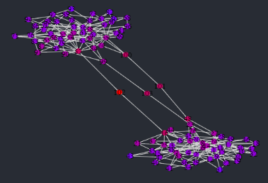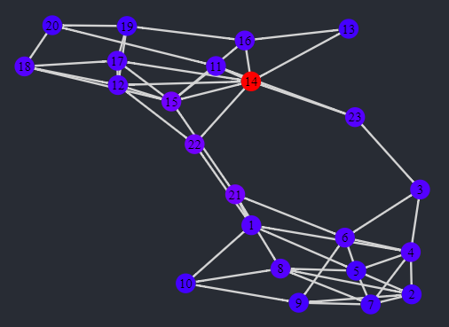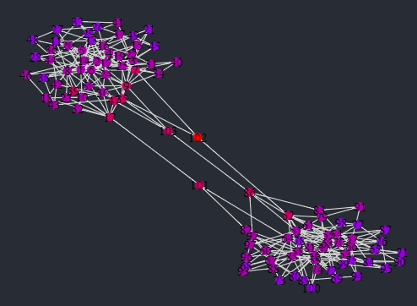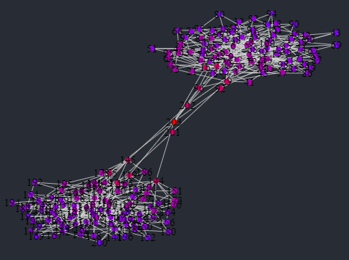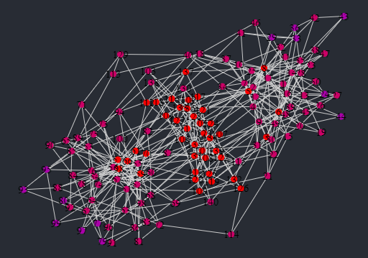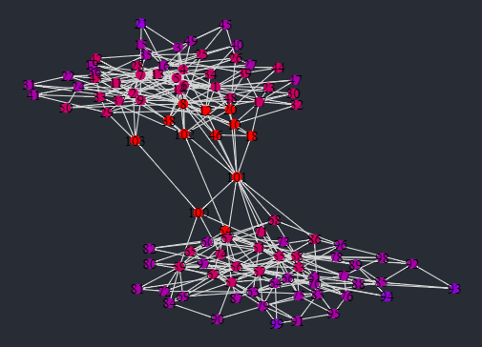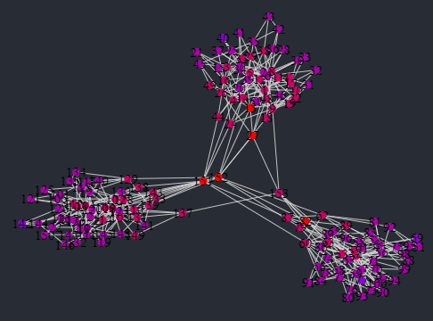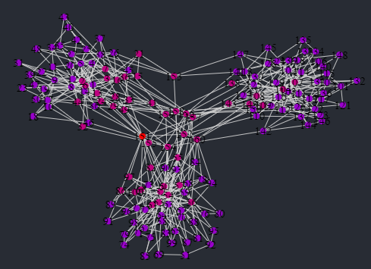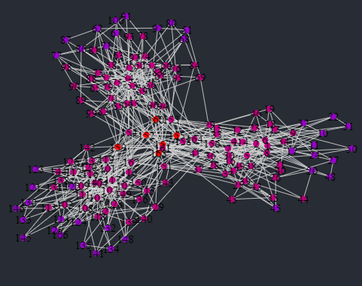

These are certainly encouraging because the areas of deepest blue align with the clusters. Furthermore, the reddest vertices are generally the bridges (except for the second graph; there weren’t enough vertices for the heat map be very finely graded). Kate suggested that it might be possible to have some threshold $b$ and take all the vertices such that $f\left(v\right)≤b$ to be the cluster points so that we don’t need to use the Wasserstein distance at all. Unfortunately, I checked and the vertices that we think are bridges do not perfectly align with the smallest values of the function. Still, these heat maps certainly support that our test will identify initial cluster points reasonably accurately.

* I also tried using the local minima of $f$ to identify initial cluster points as we discussed last week. It found essentially the same vertices as the test where we identify the “jump” in the 1-cycle births, since that jump is measuring local behavior anyway. I don’t think it’s worth adding this extra layer of complexity.
* I wrote a draft of my paper and sent it to Kate; she intends to give me feedback some time next week. I’ve also started thinking about the oral presentation to the TDA group, although I haven’t started writing it yet.
* Kate wants to try proving some threshold on the accuracy of the algorithm for a particular class of graphs, so I’ll be working on that next week.

Week 10 (10.02.2020-14.02.2020)

* As per Kate’s suggestion, I’ve been trying to prove something about the accuracy of the algorithm on a particular class of graphs, called stochastic block models. These are constructed as follows:

1. Let $n$ denote the number of vertices in the graph and fix a partition of $\left\{1,…,n\right\}$ into $r$ distinct communities, call them $C_{1},…,C_{r}$.
2. Construct an $r×r$ symmetric probability matrix $P$. Given two vertices $u∈C_{i}$ and $v∈C_{j}$, the probability that an edge exists between $u$ and $v$ is $P_{i,j}$.

This construction generalizes Erdös-Renyi models, where $P_{i,j}=p$ for some constant $p∈\left[0,1\right]$. In the Erdös-Renyi model, there is only one community.

* For our purposes, we’re starting with the easy case that there are only two clusters. Our stochastic block model then has 3 communities: two outer clusters $C_{1}$ and $C_{2}$ and a community $B$ between them which is the bridges. Ideally, our algorithm would perfectly identify all of $B$ and not identify any vertices in $C_{1}$ or $C_{2}$. Our probability matrix looks like

$$P=\left[\begin{matrix}p & i & 0 \\ i & q & j \\ 0 & j & r\end{matrix}\right]$$

The $0$ s are because we do not allow $C_{1}$ and $C_{2}$ to be connected except through $B$.

* Because all of our graphs are connected, we want this model to be too. To make this reasonable, we assume that $p>\frac{\ln\left|C_{1}\right|}{\left|C_{1}\right|},r>\frac{\ln\left|C_{2}\right|}{\left|C_{2}\right|},i>\frac{1}{\left|C_{1}\right|\left|B\right|},j>\frac{1}{\left|B\right|\left|C_{2}\right|}$. The lower bounds on $p$ and $r$ are because $C_{1}$ and $C_{2}$ are self-contained Erdös-Renyi models. In their 1960 paper *On the Evolution of Random Graphs* (<http://www.leonidzhukov.net/hse/2018/sna/papers/erdos-1960-10.pdf>), Erdös and Renyi proved that $\frac{\ln\left(n\right)}{n}$ was a sharp threshold on connectedness, so if the probability is greater than this value then the graph is almost surely connected. The lower bounds on $i$ and $j$ are just so that the expected number of edges between $C_{1}$ and $B$ and $B$ and $C_{2}$ is at least .
* A room with white walls

  Description automatically generatedA room with white walls

  Description automatically generatedI did most of the work on whiteboards, so I won’t repeat it here. These are pictures of those whiteboards:
* Kate pointed out a few mistakes with my working (mostly due to me being incapable of using inclusion-exclusion counting), but she thinks this approach seems feasible. Since all of the assessment for the ASC is due next week, I’m going to put this on hold while I finish up the project officially, but I intend to keep working on it during the semester (at a slower pace) and I’ll come back to this then.
* I received Kate’s feedback on the draft of my paper and I’ve been editing it accordingly. I contacted Marian about some citations for it being hard to rigorously define a bridge, as well as some saying that the algorithm actually has some practical applications.

Week 11 (17.02.2020-21.02.2020)

* I wrote my speech and slides for the presentation on Thursday. I also met with Yossi to discuss them and the paper. He gave me some feedback on both.
* We had a Zoom meeting with Marian on Tuesday to discuss the project and how we’re going to coordinate during the semester. We discussed where the project is up to and I sent him my paper so that he could familiarize himself with the algorithm. He suggested that we try learning the value of $d$ (the upper bound on Wasserstein distance) but I want to try Kate’s idea first because I don’t know anything about fitting regressions. Here is a picture of his whiteboard.

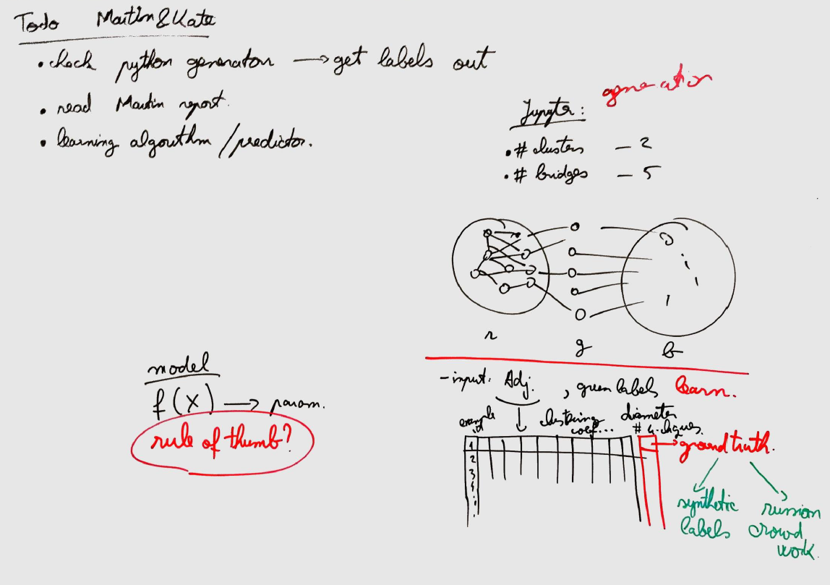

* I’m including a table showing the output of the final iteration of the algorithm applied to the example graphs along with the associated values of $d$ (this is the only parameter we still need to change by hand). I no longer have the code used to generate every iteration of the graphs (both because of the Atom error and because I’ve edited over it), but I want to give Kate and Vanessa images to show that the algorithm actually works, along with values if they want to check for themselves.

There are more vertices at the edges of clusters being identified than I had hoped. These appeared when we switched over from the Eirene computation of Wasserstein distance to the $l^{2}$ norm (so the fact that the wrong value of Wasserstein distance was being computed did have an effect). It seems like a reasonable trade-off for a huge increase in efficiency though.

|  |  |
| --- | --- |
| Value of $d$ | Final Output of Graph |
| $$15$$ |  |
| $$3$$ |  |
| $$16$$ |  |
| $$21$$ |  |
| $$11$$ |  |
| $$26$$ |  |
| $$28$$ |  |
| $$9$$ |  |
| $$14$$ |  |